LLRF OPI for SRF Tests at ATLAS: Screen Description
Hengjie Ma
6-18-2012
This OPI screen description applies to LLRF-4 code version V09/29/2011.
- General – In this OPERATOR screen, the LLRF is in open-loop control mode for all rf operations. The proposed screen layout is shown in Figure below. There are four display groups
  - rf signal waveforms display pane,
  - rf manual controls pane,
  - auto-sequencer pane for frequency scan, power sweep,
  - LLRF-4 register , and interlock status display panes
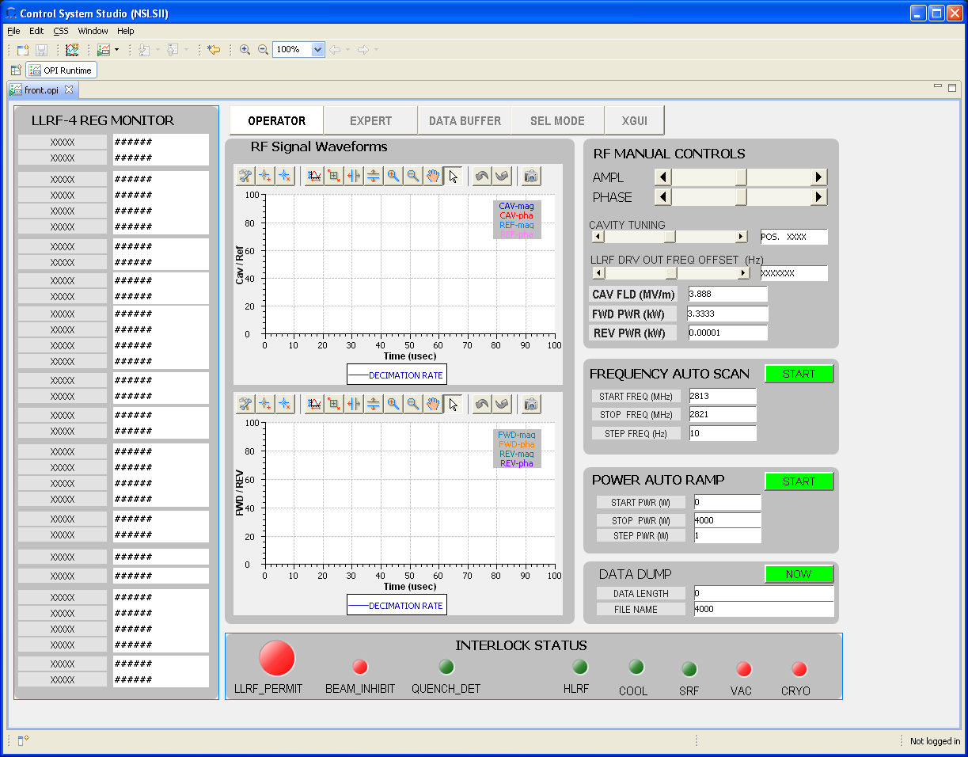
- RF Signal Waveforms pane

Appendix A: LLRF-4 register reset values
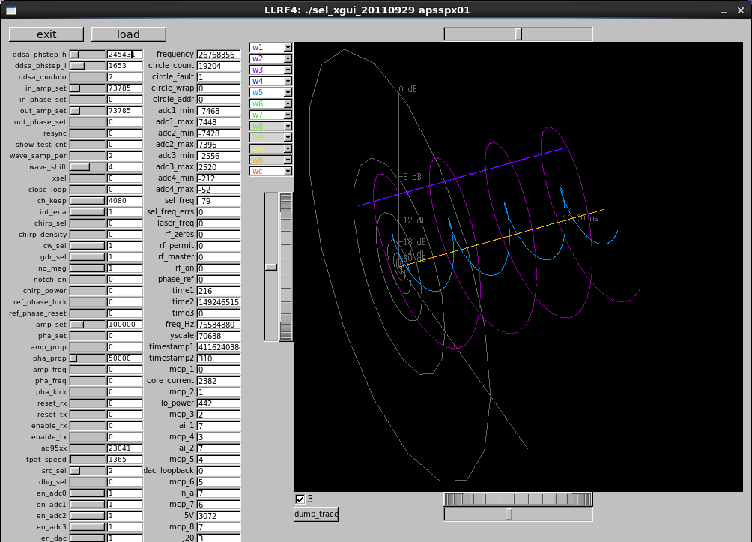
Name | Value | Name | Value | Name | Value | Name | Value
ddsa_phstep_h | 2454311 | wave_samp_per | 3
ddsa_phstep_l | 1653 | Wave_shift | 5
ddsa_modulo | 7 | Out_amp_set | 73785
In_amp_set | 73785 | xsel | 0
In_phase_set | 0 | Close_loop | 0
Out_amp_set | 73785
Out_phase_set | 0

